Space Vortex Theory as a Candidate Framework for Subatomic Field Structure

# Abstract

This study presents a comparative exploration of Space Vortex Theory (SVT) as a geometric and energetic alternative to quantum orbital models, emphasizing electron configuration and molecular energy densities. Using 3D numerical simulation and visualization, we modeled the dynamics of multi-vortex interactions and Coulombic potentials. Our simulations demonstrate radial symmetry, confinement structures, and energy density distributions remarkably aligned with standard quantum mechanics, including the hydrogen 2p orbital and H₂O bond behavior. Novel insights into the toroidal and spheroidal organization of field energy suggest SVT may provide a compelling complementary interpretation of atomic-scale structure.

# Figures and Visual Evidence

ev_3d_over_time.png

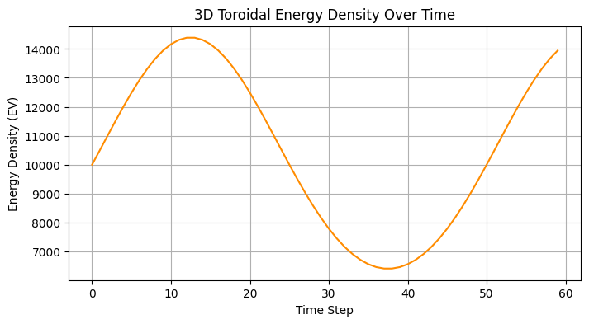

ev_over_time.png

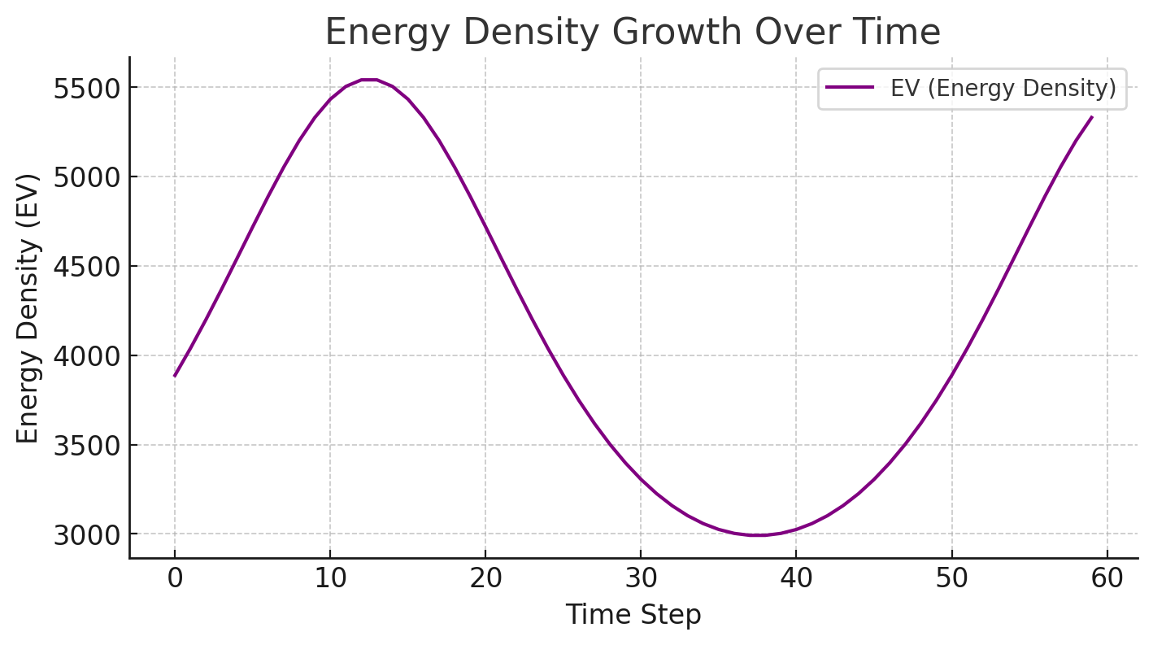

ChatGPT Image Jun 4, 2025, 03_35_40 PM.png

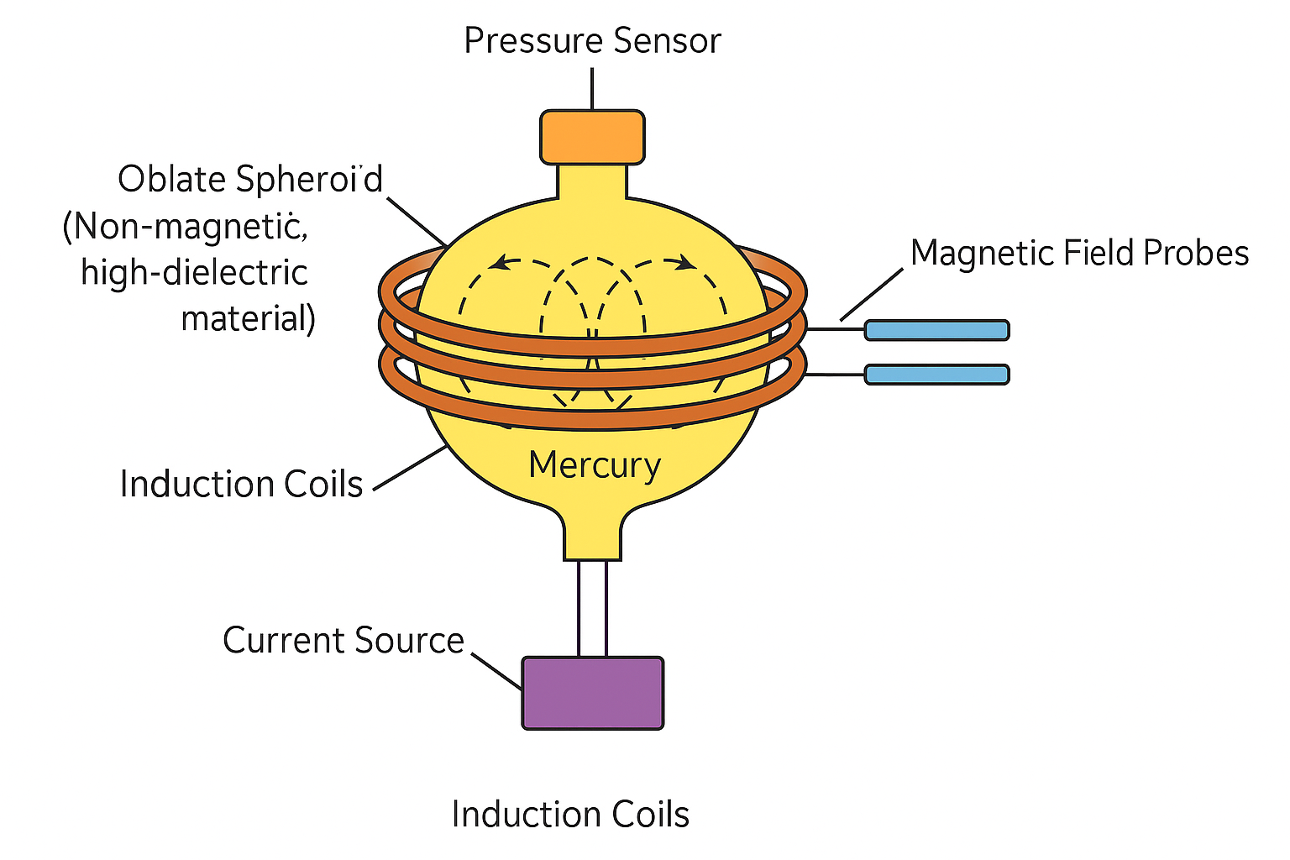

electron_vortext_interaction_field_2e_model.webp

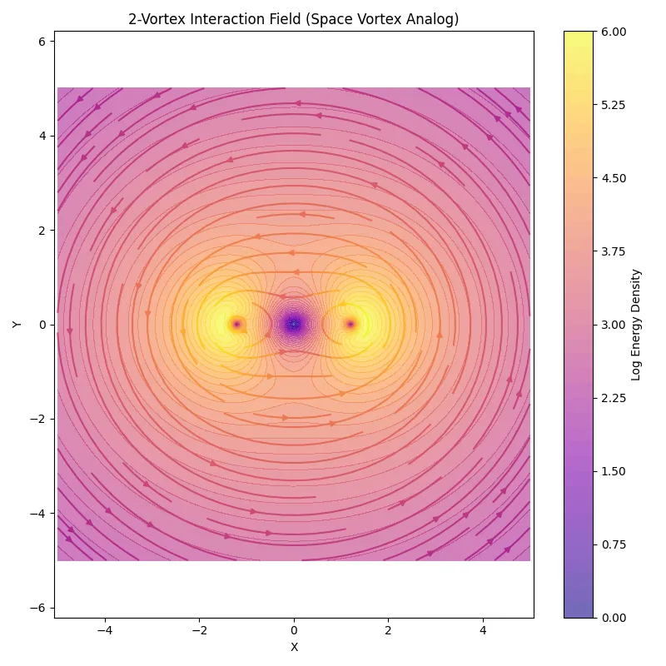

space_vortex_h2o.webp

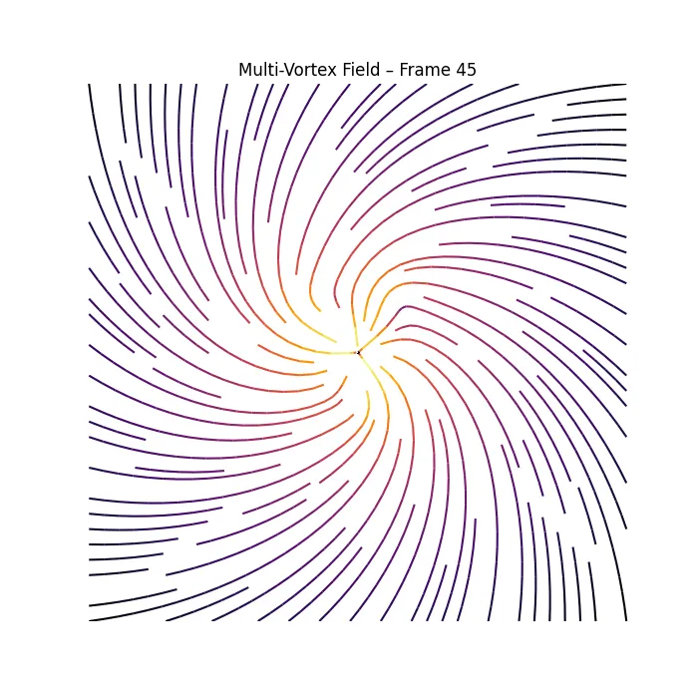

svt_vs_standard_model_orbital_and_energy_density.webp

